Linear Regression Algorithms

✅ Definition:
Linear regression assumes a linear relationship between the input features (X) and the output (Y).
✳️ Basic Equation:
Y=β0​+β1​X1​+β2​X2​+⋯+βn​Xn​+ϵ
Where:
- β0 ​ is the intercept
- βi ​ are coefficients
- ϵ is the error term

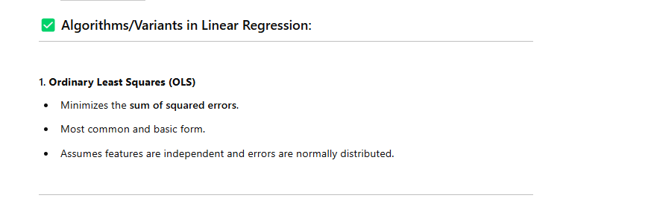
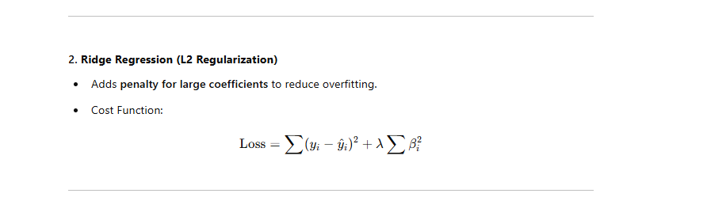
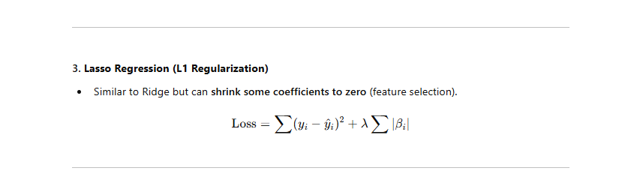

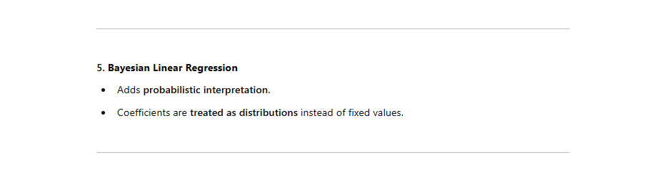



Non Linear Regression
✅ Definition:
The relationship between features and the target is non-linear, meaning it cannot be modeled using a straight line.

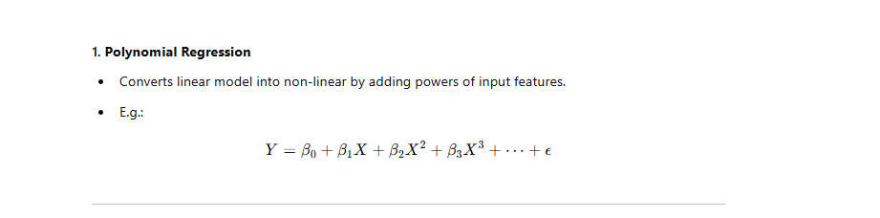

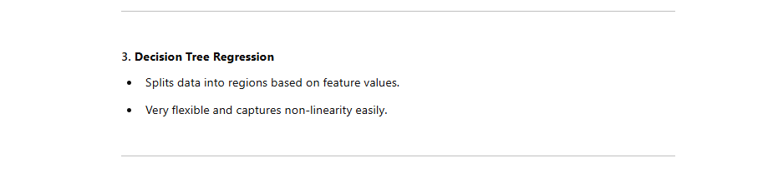
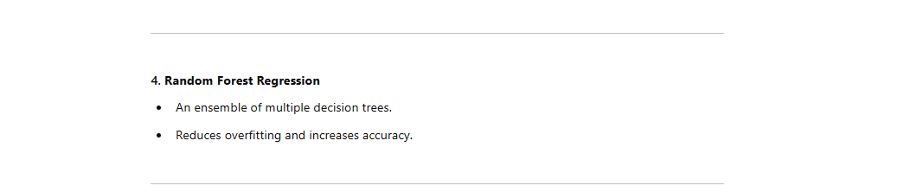

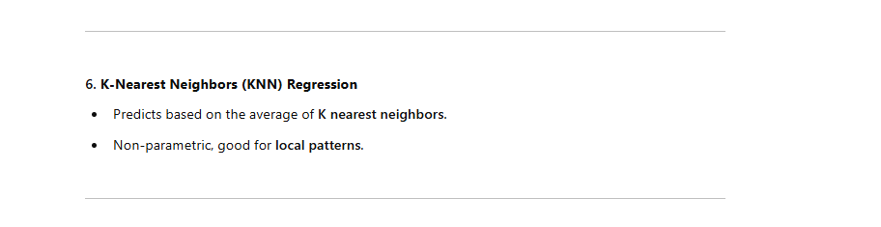
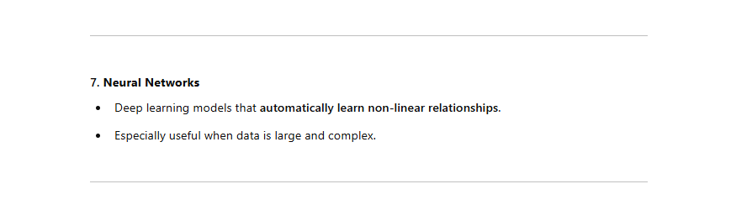
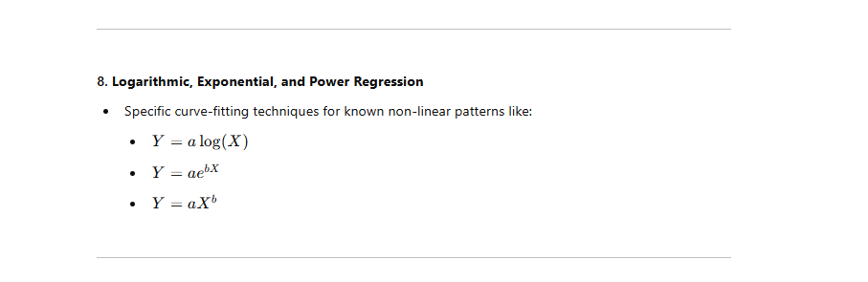

🆚 Linear vs Non-Linear Regression
Feature | Linear Regression | Non-Linear Regression
Shape | Straight line | Curve or complex shape
Complexity | Low | Medium to High
Interpretability | Easy | Sometimes difficult
Examples | OLS, Ridge | Polynomial, SVR, Trees
Speed | Fast | Slower depending on algorithm

